***Rapport d’optimisation***

*Original SEO report :*

Desktop :

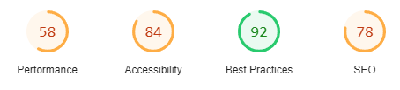

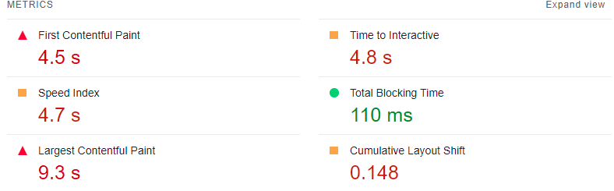

Mobile :

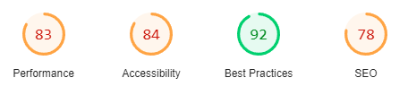

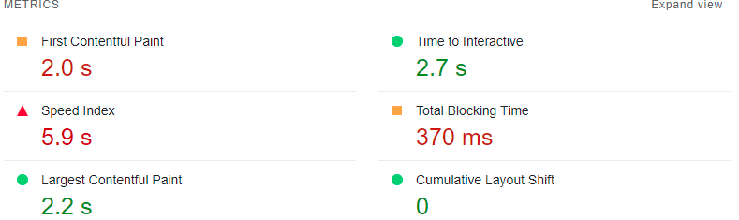

*1.Description text and [lang] attribute SEO report:*

Desktop:

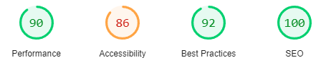

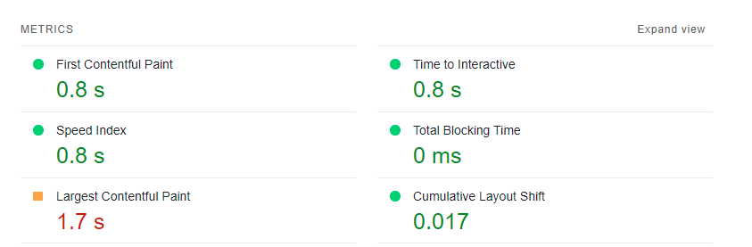

Mobile:

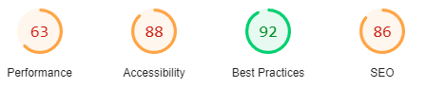

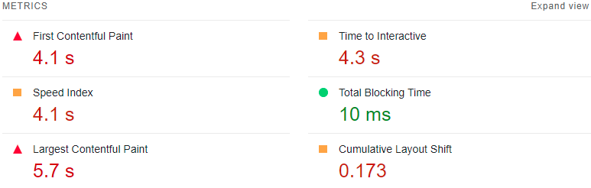

*Document doesn't use legible font sizes:*

Desktop:

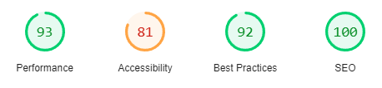

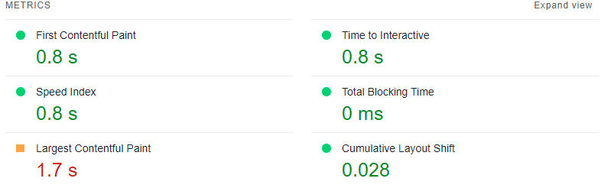

Mobile:

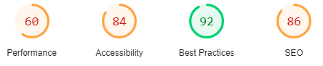

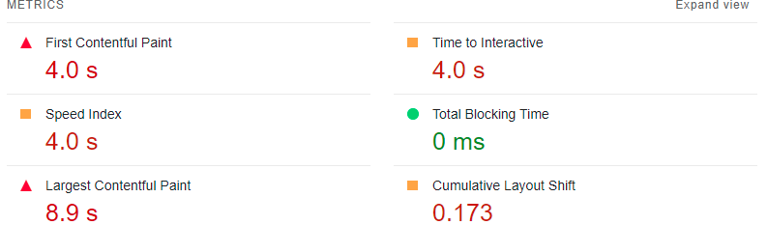

*Background and foreground colors do not have a sufficient contrast ratio:*

Desktop:

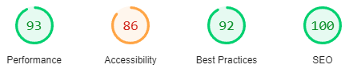

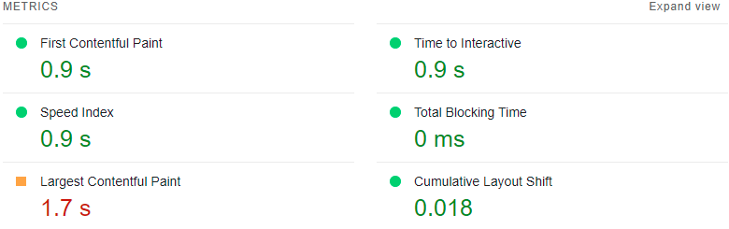

Mobile:

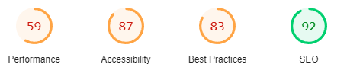

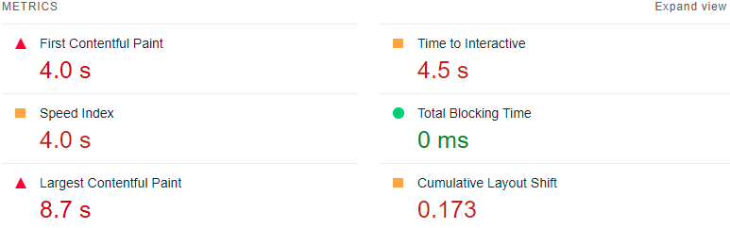

*Links do not have a discernible name:*

Desktop:

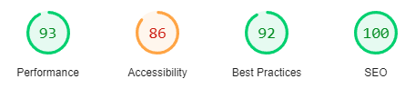

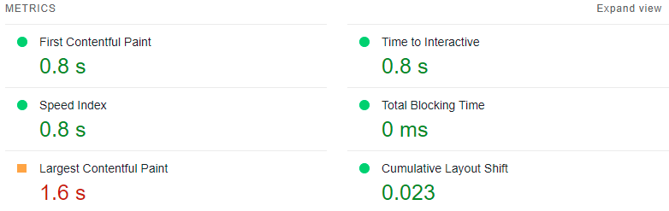

Mobile:

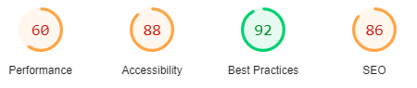

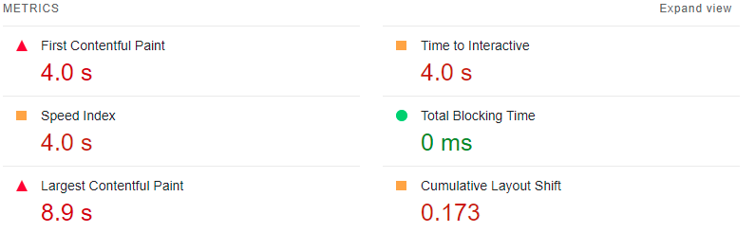

*Heading elements are not in a sequentially-descending order:*

Desktop:

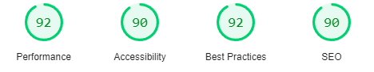

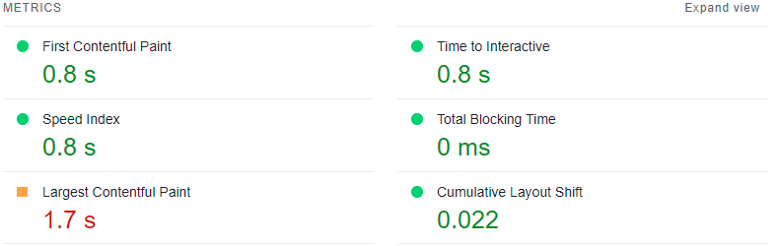

Mobile:

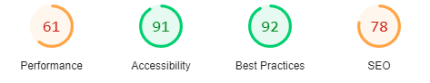

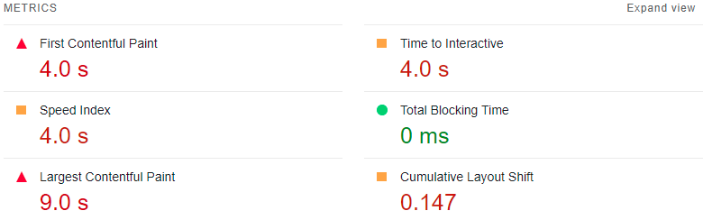

*Footer links are broken:*

Desktop:

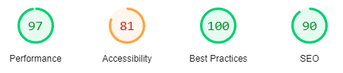

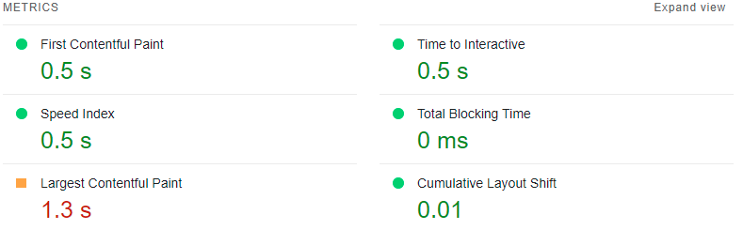

Mobile:

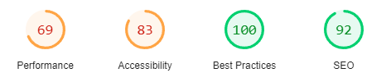

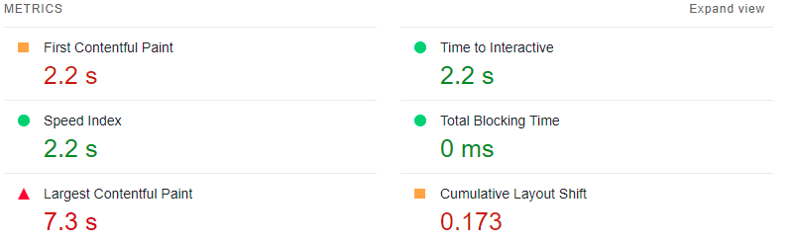

*Avoid enormous network payloads:*

Desktop:

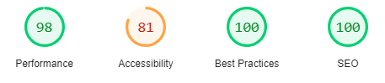

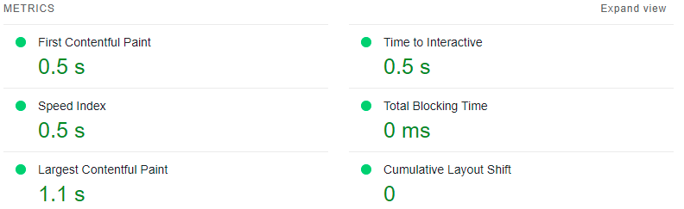

Mobile:

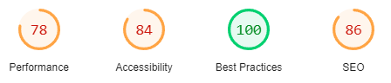

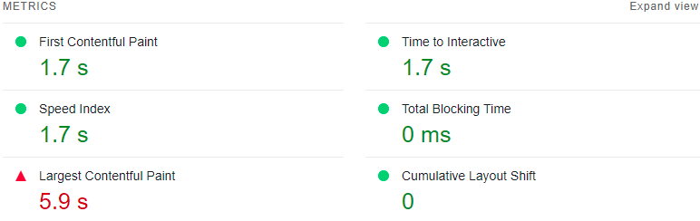

*Delete hidden text:*

Desktop:

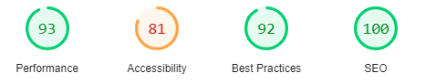

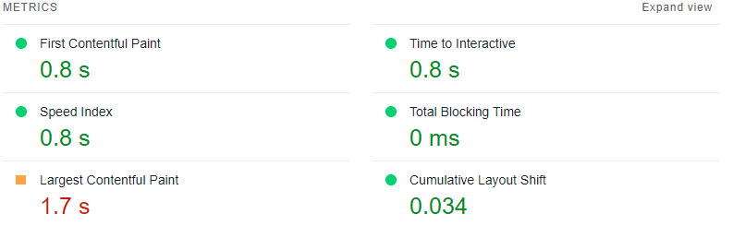

Mobile:

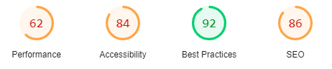

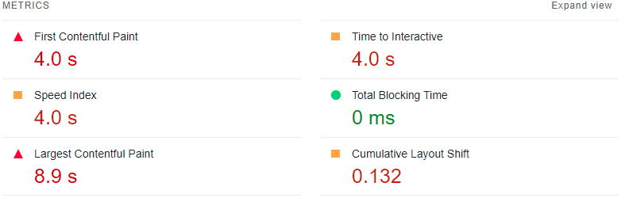

*Serve images in next-gen formats:*

Desktop:

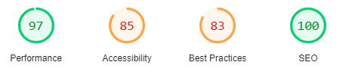

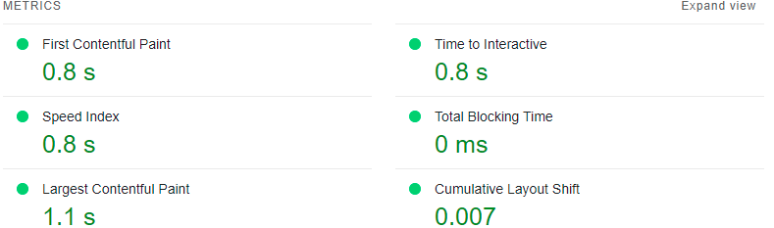

Mobile:

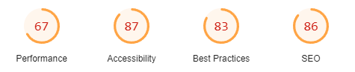

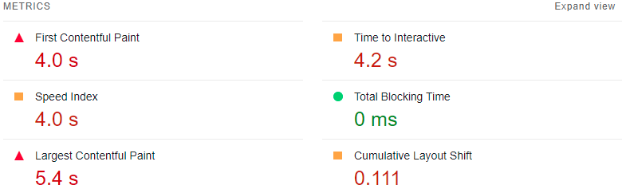

*Mobile Friendly?*

*Final version:*

Desktop:

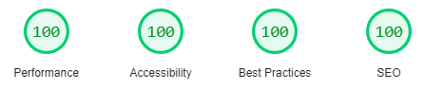

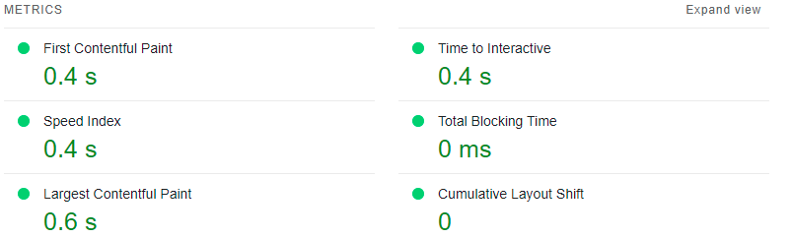

Mobile:

